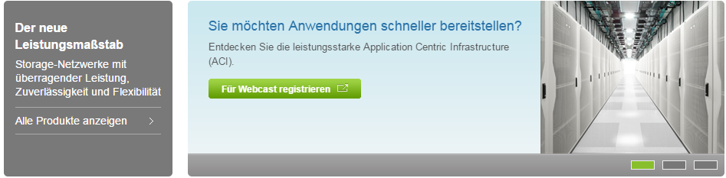

6

5

4

3

2

1

14

13

7

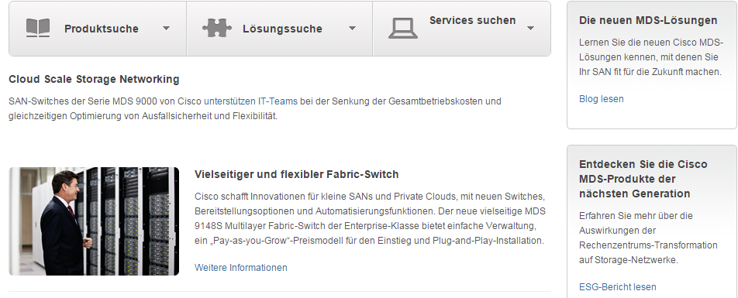

15

9

12

11

10

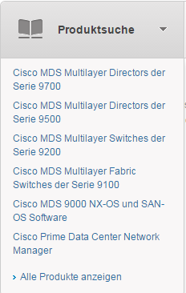

8

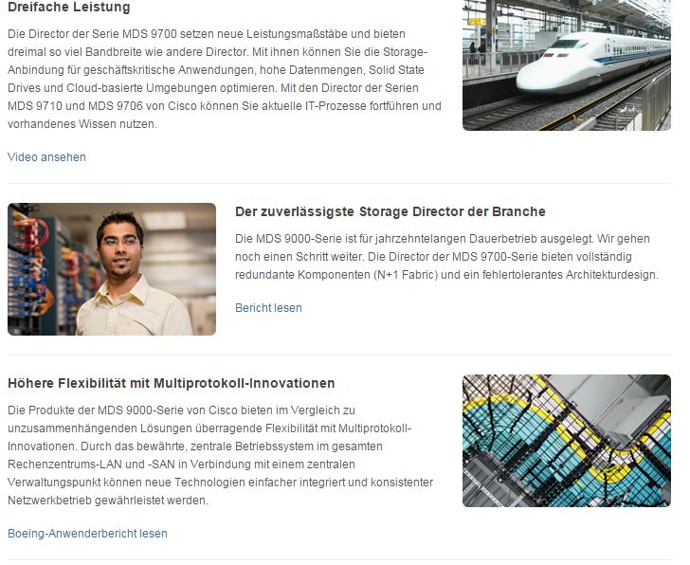

21

20

19

18

17

16

23

22

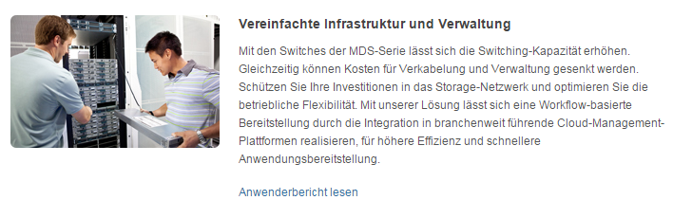

24

|  |  |  |  |
| --- | --- | --- | --- |
| 1 | /content/<locale>/products/storage-networking/index/jcr:content/content_parsys/overview/layout-overview/gd12v1/gd12v1-left/primary_cta/title |  | Select(“div.gd-left”).select(“div. c47-pilot”).getElementByTag(“h3”) |
| 2 | /content/<locale>/products/storage-networking/index/jcr:content/content_parsys/overview/layout-overview/gd12v1/gd12v1-left/primary_cta/description |  | Select(“div.gd-left”).select(“div. c47-pilot”).getElementByTag(“p”) |
| 3 | /content/<locale>/products/storage-networking/index/jcr:content/content_parsys/overview/layout-overview/gd12v1/gd12v1-left/primary_cta/linktext  /content/<locale>/products/storage-networking/index/jcr:content/content_parsys/overview/layout-overview/gd12v1/gd12v1-left/primary_cta/linkurl |  | Select(“div.gd-left”).select(“div. c47-pilot”).getElementByTag(“a”)  Select(“div.gd-left”).select(“div. c47-pilot”).getElementByTag(“a”) attr(“href”) |
| 4 | /content/<locale>/products/storage-networking/index/jcr:content/content_parsys/overview/layout-overview/gd12v1/gd12v1-right/hero_large/heropanel*/title |  | Select(“div.gd-right”).select(“div.c50-pilot”)-this will return elements for(each elements){getElementByTag(“h2”)} |
| 5 | /content/<locale>/products/storage-networking/index/jcr:content/content_parsys/overview/layout-overview/gd12v1/gd12v1-right/hero_large/heropanel*/description |  | Select(“div.gd-right”).select(“div.c50-pilot”)-this will return elements for(each elements){getElementByTag(“p”)} |
| 6 | /content/<locale>/products/storage-networking/index/jcr:content/content_parsys/overview/layout-overview/gd12v1/gd12v1-right/hero_large/heropanel*/linktext  /content/<locale>/products/storage-networking/index/jcr:content/content_parsys/overview/layout-overview/gd12v1/gd12v1-right/hero_large/heropanel*/linkurl |  | Select(“div.gd-right”).select(“div.c50-pilot”)-this will return elements for(each elements){getElementByTag(“a”)}  Select(“div.gd-right”).select(“div.c50-pilot”)-this will return elements for(each elements){getElementByTag(“a”)attr(“href”)} |
| 7 | /content/<locale>/products/storage-networking/index/jcr:content/content_parsys/overview/layout-overview/gd12v2_0/gd12v2-left/selectorbarlarge/selectorbarpanel*/title  /content/<locale>/products/storage-networking/index/jcr:content/content_parsys/overview/layout-overview/gd12v2_0/gd12v2-left/selectorbarlarge/selectorbarpanel*/titleurl |  | Select(“div.gd-left”).select(“div.c58-pilot”)-this will return elements for(each elements) { getElementByTag(“h2”).getElementByTag(“a”)}  Select(“div.gd-left”).select(“div.c58-pilot”)-this will return elements for(each elements) { getElementByTag(“h2”).getElementByTag(“a”)attr(“href”)} |
| 8 | /content/<locale>/products/storage-networking/index/jcr:content/content_parsys/overview/layout-overview/gd12v2_0/gd12v2-left/selectorbarlarge/selectorbarpanel*/allinktext  /content/<locale>/products/storage-networking/index/jcr:content/content_parsys/overview/layout-overview/gd12v2_0/gd12v2-left/selectorbarlarge/selectorbarpanel*/allinkurl |  | Select(“div.gd-left”).select(“div.c58-pilot”)-this will return elements for(each elements) { getElementByTag(“h2”).getElementByTag(“a”)}  Select(“div.gd-left”).select(“div.c58-pilot”)-this will return elements for(each elements) { getElementByTag(“h2”).getElementByTag(“a”)attr(“href”)} |
| 9 | /content/<locale>/products/storage-networking/index/jcr:content/content_parsys/overview/layout-overview/gd12v2_0/gd12v2-left/text/text |  | Select(“div.c00-pilot”).getElementByTag(“h2”).getElementByTag(“p”) |
| 10 | /content/<locale>/products/storage-networking/index/jcr:content/content_parsys/overview/layout-overview/gd12v2_0/gd12v2-left/spotlight_large_v2/title |  | Select(“div.c11-pilot”).getElementByTag(“h2”) |
| 11 | /content/<locale>/products/storage-networking/index/jcr:content/content_parsys/overview/layout-overview/gd12v2_0/gd12v2-left/spotlight_large_v2/description |  | Select(“div.c11-pilot”).getElementByTag(“p”) |
| 12 | /content/<locale>/products/storage-networking/index/jcr:content/content_parsys/overview/layout-overview/gd12v2_0/gd12v2-left/spotlight_large_v2/linktext  /content/<locale>/products/storage-networking/index/jcr:content/content_parsys/overview/layout-overview/gd12v2_0/gd12v2-left/spotlight_large_v2/linkurl |  | Select(“div.c11-pilot”).getElementByTag(“a”)  Select(“div.c11-pilot”).getElementByTag(“a”)attr(“href”) |
| 13 | /content/<locale>/products/storage-networking/index/jcr:content/content_parsys/overview/layout-overview/gd12v2_0/gd12v2-right/tile_bordered*/title |  | Select(“div.gd-right”).select(“div.c23-pilot”)-this will return elements for(each elements){getElementByTag(“h2”)} |
| 14 | /content/<locale>/products/storage-networking/index/jcr:content/content_parsys/overview/layout-overview/gd12v2_0/gd12v2-right/tile_bordered*/description |  | Select(“div.gd-right”).select(“div.c23-pilot”)-this will return elements for(each elements){getElementByTag(“p”)} |
| 15 | /content/<locale>/products/storage-networking/index/jcr:content/content_parsys/overview/layout-overview/gd12v2_0/gd12v2-right/tile_bordered*/linktext  /content/<locale>/products/storage-networking/index/jcr:content/content_parsys/overview/layout-overview/gd12v2_0/gd12v2-right/tile_bordered*/linkurl |  | Select(“div.gd-right”).select(“div.c23-pilot”)-this will return elements for(each elements){getElementByTag(“a”)}  Select(“div.gd-right”).select(“div.c23-pilot”)-this will return elements for(each elements){getElementByTag(“a”) attr(“href”)} |
| 16 | /content/<locale>/products/storage-networking/index/jcr:content/content_parsys/overview/layout-overview/gd12v2_0/gd12v2-left/spotlight_large_0/title |  | Select(“div.c11-pilot”).getElementByTag(“h2”) |
| 17 | /content/<locale>/products/storage-networking/index/jcr:content/content_parsys/overview/layout-overview/gd12v2_0/gd12v2-left/spotlight_large_0/description |  | Select(“div.c11-pilot”).getElementByTag(“p”) |
| 18 | /content/<locale>/products/storage-networking/index/jcr:content/content_parsys/overview/layout-overview/gd12v2_0/gd12v2-left/spotlight_large_0/linktext  /content/<locale>/products/storage-networking/index/jcr:content/content_parsys/overview/layout-overview/gd12v2_0/gd12v2-left/spotlight_large_0/linkurl |  | Select(“div.c11-pilot”).getElementByTag(“a”)  Select(“div.c11-pilot”).getElementByTag(“a”)attr(“href”) |
| 19 | /content/<locale>/products/storage-networking/index/jcr:content/content_parsys/overview/layout-overview/gd12v2_0/gd12v2-left/spotlight_large_1/title |  | Select(“div.c11-pilot”).getElementByTag(“h2”) |
| 20 | /content/<locale>/products/storage-networking/index/jcr:content/content_parsys/overview/layout-overview/gd12v2_0/gd12v2-left/spotlight_large_1/description |  | Select(“div.c11-pilot”).getElementByTag(“p”) |
| 21 | /content/<locale>/products/storage-networking/index/jcr:content/content_parsys/overview/layout-overview/gd12v2_0/gd12v2-left/spotlight_large_1/linktext  /content/<locale>/products/storage-networking/index/jcr:content/content_parsys/overview/layout-overview/gd12v2_0/gd12v2-left/spotlight_large_1/linkurl |  | Select(“div.c11-pilot”).getElementByTag(“a”)  Select(“div.c11-pilot”).getElementByTag(“a”)attr(“href”) |
| 22 | /content/<locale>/products/storage-networking/index/jcr:content/content_parsys/overview/layout-overview/gd12v2_0/gd12v2-left/spotlight_large_2/title |  | Select(“div.c11-pilot”).getElementByTag(“h2”) |
| 23 | /content/<locale>/products/storage-networking/index/jcr:content/content_parsys/overview/layout-overview/gd12v2_0/gd12v2-left/spotlight_large_2/description |  | Select(“div.c11-pilot”).getElementByTag(“p”) |
| 24 | /content/<locale>/products/storage-networking/index/jcr:content/content_parsys/overview/layout-overview/gd12v2_0/gd12v2-left/spotlight_large_2/linktext  /content/<locale>/products/storage-networking/index/jcr:content/content_parsys/overview/layout-overview/gd12v2_0/gd12v2-left/spotlight_large_2/linkurl |  | Select(“div.c11-pilot”).getElementByTag(“a”)  Select(“div.c11-pilot”).getElementByTag(“a”)attr(“href”) |

Diversion:

Link Url need to be added in the aem for spotlight_large_0 and spotlight_large_v2